Key Vocabulary
bakery | 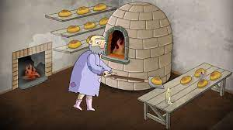 | A place that makes bread and cakes.
diary | 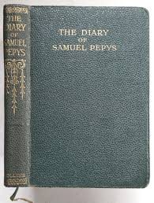 | A book that people write about their lives in.
embers | 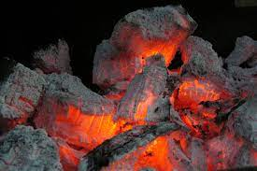 | Small pieces of glowing coal or wood in a dying fire.
eyewitness | 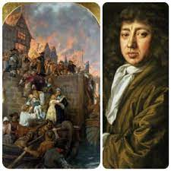 | A person who has seen something and can give a description of it.
flammable | 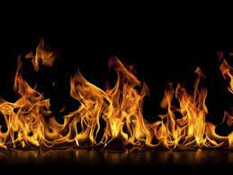 | When something burns easily.
natural | 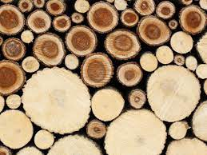 | When a material is used in its raw state e.g. a wooden door.
manufactured | 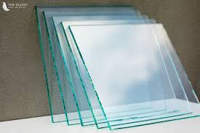 | When a raw material has been changed into a new material e.g. wood into paper.
I should already know:
- Nottingham is the city nearest to where we live.
- London is the capital city of England.
- The names of a variety of everyday materials, including wood, plastic, glass, metal, water, and rock.
- Simple physical properties of a variety of everyday materials.
Key events and facts
When and where did the fire start?  The fire started on Sunday 2nd September 1666 in Thomas Farrinor’s bakery on Pudding Lane. It lasted for 5 days.  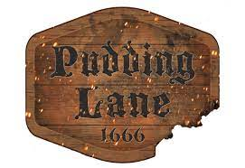 | Why did the fire spread so quickly?  The weather was hot and it hadn’t rained for a long time. Houses in London were mainly built of wood and straw which is flammable, especially when it is dry.  The houses were very close together so the fire spread easily.  Strong winds were blowing which helped the flames to spread. | 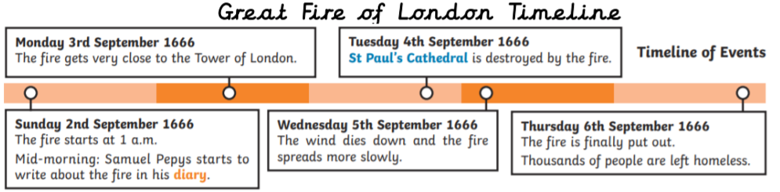  How did people try to put the fire out?  There was no fire brigade so people used leather buckets and water squirts filled with water from the River Thames. King Charles II ordered buildings to be pulled down to stop the flames from spreading.  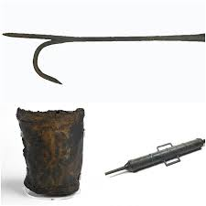
What happened after the fire?  13,200 houses were destroyed by the fire and 70,000 people were left homeless. Many left London to live elsewhere and some slept in tents.  An organised fire brigade was established and water engines were designed that gave a continuous stream of water when pumped. | What is a material?  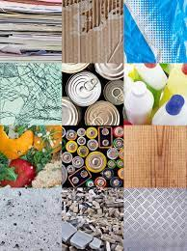  A material is any substance that has a name. for example; paper, wood, water, stone, plastic, metal, cotton. | Who was Cai Lun?  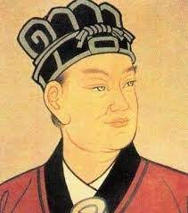  Cai Lun invented paper in 105. He used the soft inner bark of a mulberry tree, bamboo fibres and water. When the mixture dried it made paper.
Key People
Samuel Pepys  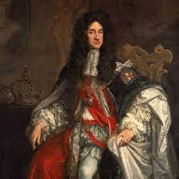  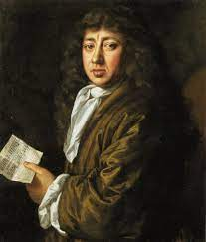  Samuel Pepys lived in London in 1666 and wrote about the fire in his diary. | Thomas Farrinor  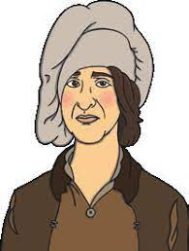  Thomas Farrinor was the owner of the bakery on Pudding Lane where the fire started. | King Charles II  King Charles II was the king of England in 1666.

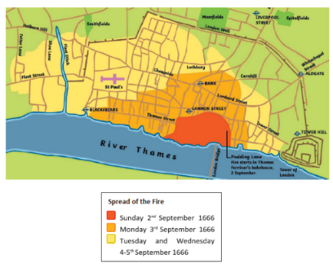

Key websites
www.fireoflondon.org.uk/game/
www.bbc.co.uk/newsround/37222884
www.bbc.co.uk/cbeebies/radio/mu-story-isabell-great-fire
www.bbc.co.uk/cbebies/puzzles/my-story-fire-of-london-quiz
https://www.bbc.co.uk/bitesize/topics/zrssgk7/articles/z9pgcdm

